aDmins add courses but pls we need a departmet first the course will be related to a department

For example department computer science, department Math……

Then he adds courses

The vertical side bar pls make it light grey in all screens not black

Also in questions!!!!!

Now when I add course

I can add exam

So we will have

Exam

Add exams

Manage exams

Add questions

Manage questions

All under exams

The problem here is when we add questions they are all in one place so if I want to add certain questions for certain exam I choose from all questions I did!! How ccome

we need the following scenario

ad exam

then course moderator or admin adds the exam and choses its type and the course related to it and also the department now

1. We add exam
2. We add questions but we need it this way..we choose the course and department and start adding a pool of questions lets say we will add 60 questions
3. So now we have 60 questions for java course under computer department
4. Now we link questions to exams weather mid term or final as the way its done but I have to open a pool related to the course not a pool related to all questions I added in website

Pls chk the timing is working and when I take exam a count time is shown for student to know the time

Also chk that I can delete any thing as we tried and some deletions are not working

Also we need student to take the exam maximum twice not as much as he can

Forums

We need the forum created either by the course moderator or the admin ..and forum has a title..forum title and a course related to it..so ppl in same course can view and answer

When I log in as student I find at my home page allcategories wit courses

When I choose a course I have to press start course to start this course

Then the side bar will have all info of course with attactments and exams appear on left also we will view the forum of course appearing below to when I click on material I view all attactment where I can doen load and so on also one more thing when I add the info of answer while creating te question and I take exam and answer wrong the info is not appearing

Course java

Material

Material

Material

Exams

Quiz1

Quiz2

Final

Forum

finish

news is added by admin and viewed in home page in a section not taking the whole page pls we need a nice home page for site as below

Hello pls we need to have a catching home page see khanacademy I need something color ful with green colcor and login and register and home and about us all on top

The name of the site is elearning academy see up login and sign up and instead of subjects it will be courses so all ppl can view the courses even visitors , btw there is no user called visitor we meant that any visitor will be able to see what courses we have and see the home page

See a simple home page when I click up on subjects u will see how it look ps go to khanacademy.org

I will add logo we need green theme pls we need nice interface please

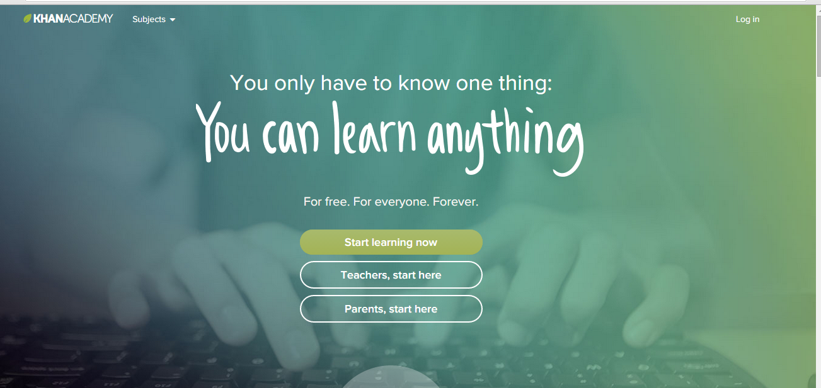

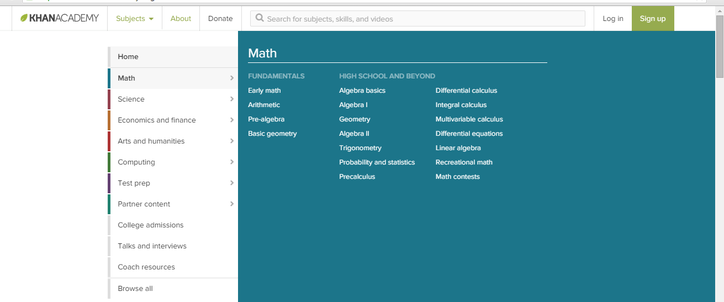

Here we clicked on math for example and we saw hat math courses they have

Main page of student he sees the courses he is working on there is start and end when I start the ocurse I will finish it so at my home pages I can see courses departments by clicking I see courses there also I can see what im currently taking

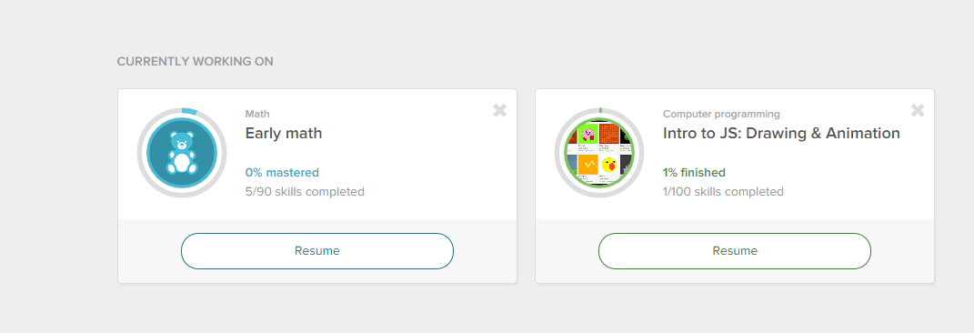

When student registers and logs in and starts a course he sees smtg like this

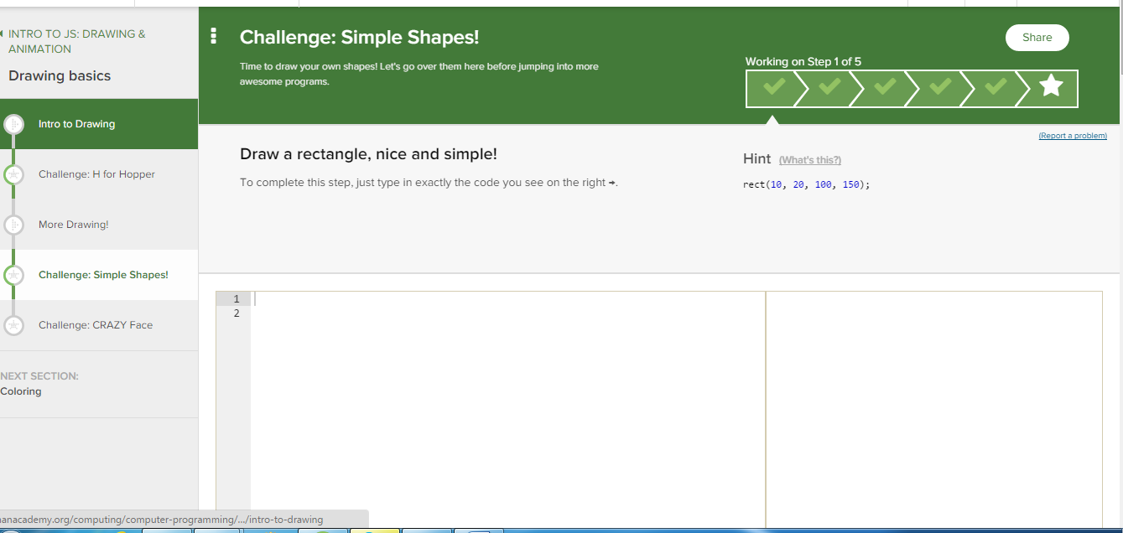

Questions should be created to a certain course so we will have a drown down list fro departmenst and courses pls we cant have all questions in one place and choose for whole website

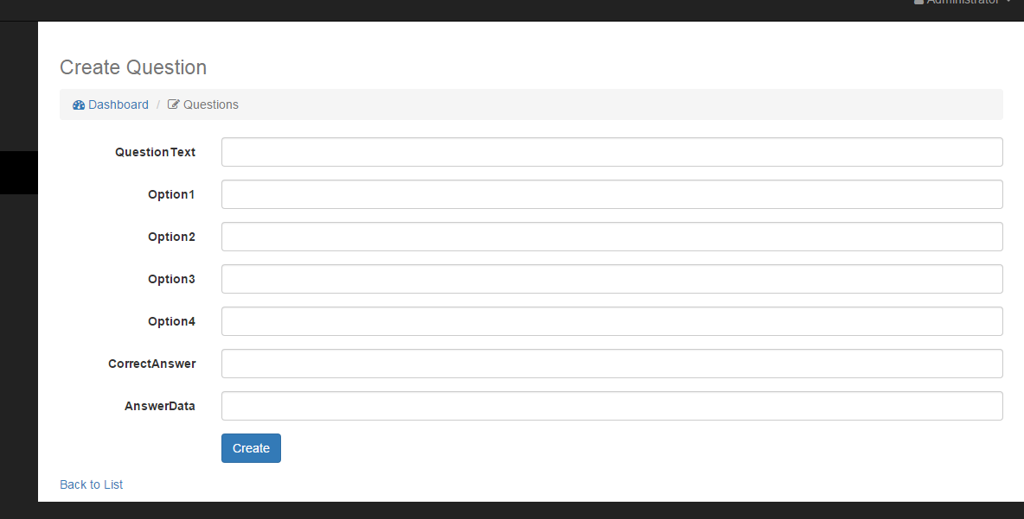

Create a forum we must have a title and a cours related to the forum so here u r missing the forum title that will have all questions related to java so we need a title for forum then question then course

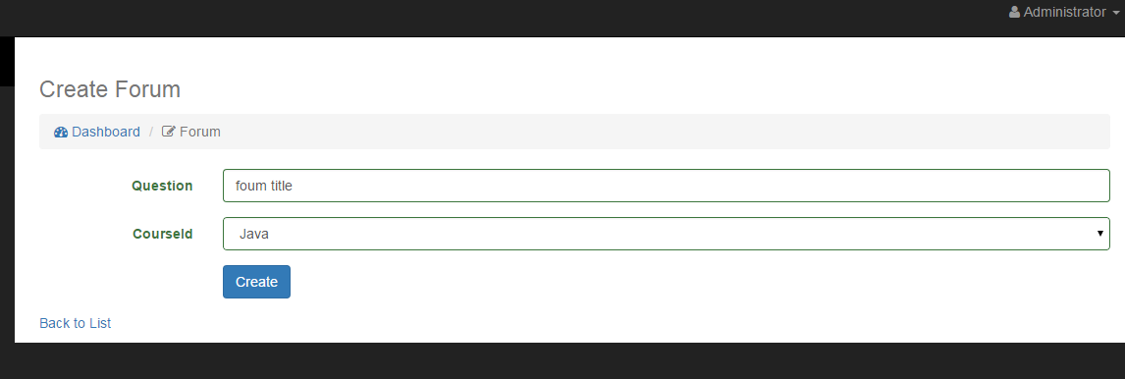

We have to be able to delete a curse pls

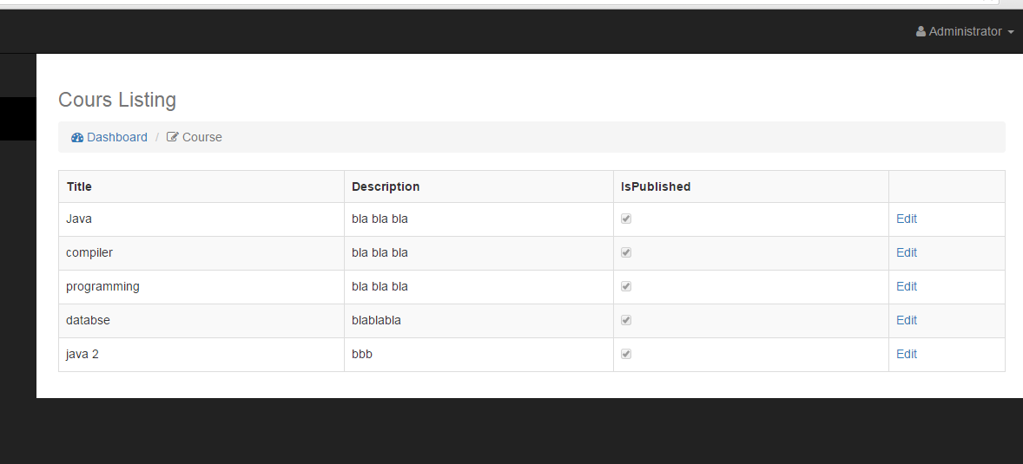

Check the date error pls here we have to choose day below 12 to wrok??

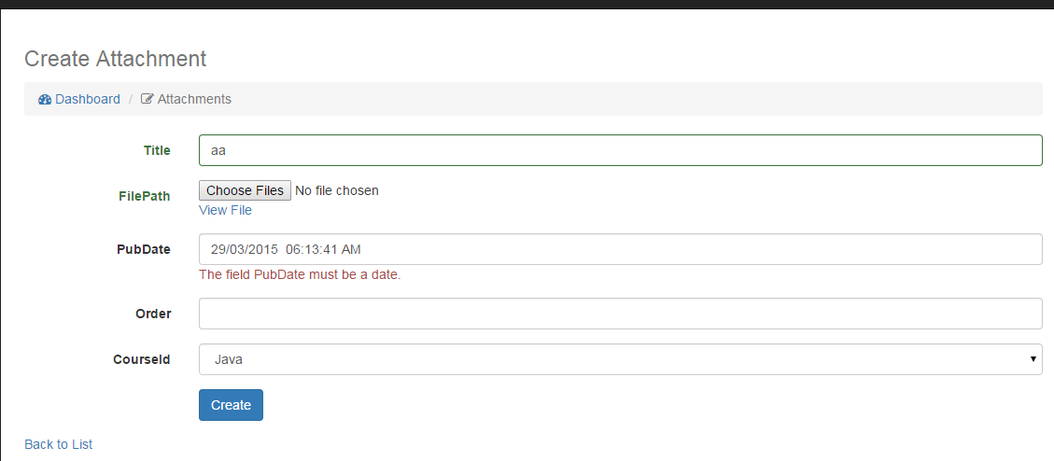

Please grades must be shown ?? here I got an F?? not E

So pls to solve this let the grades be a % for example I answered 4 from 5 u say the percet, I answered 89 from 100 u tell me percent and so on

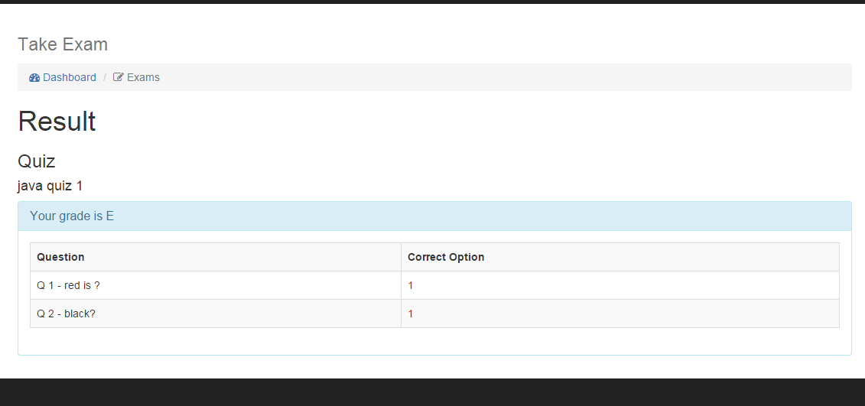

Hereeeeeeeeeeee as I ased pls make pool for every course not for all the courses its really not applicable at all

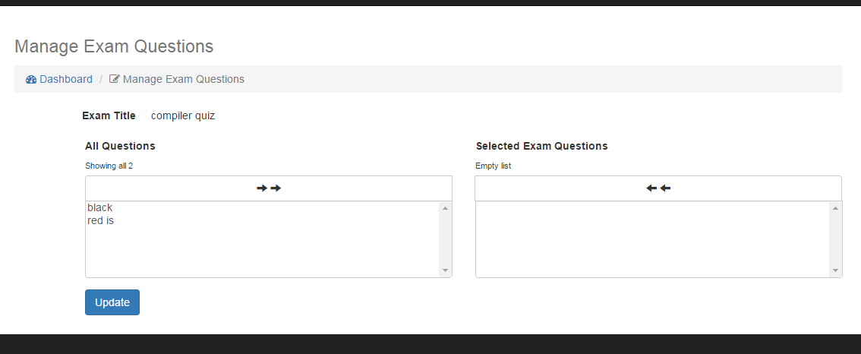

Exams wont be available like this each course has its exams student home page he will see courses and chooses courses to start when he starts a course he can view exam as I showed u earlier

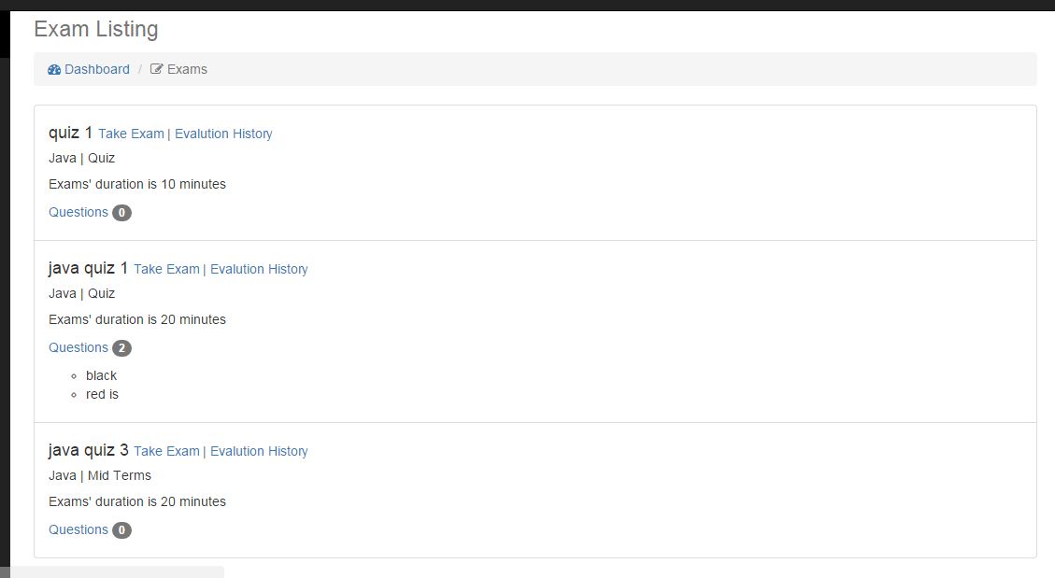

Answer data is not viewed when I submit the test I have to know when I answer wrong this data must appear pls I added here and as we said the question must be related to a course and department



Please remove the role visitor we mean any one who will see the home page is a visitor

